**Screenshot Descriptions: Automated ML Experiment Setup**

The Bank Marketing dataset was uploaded from a local source and appropriately named.

Uploaded

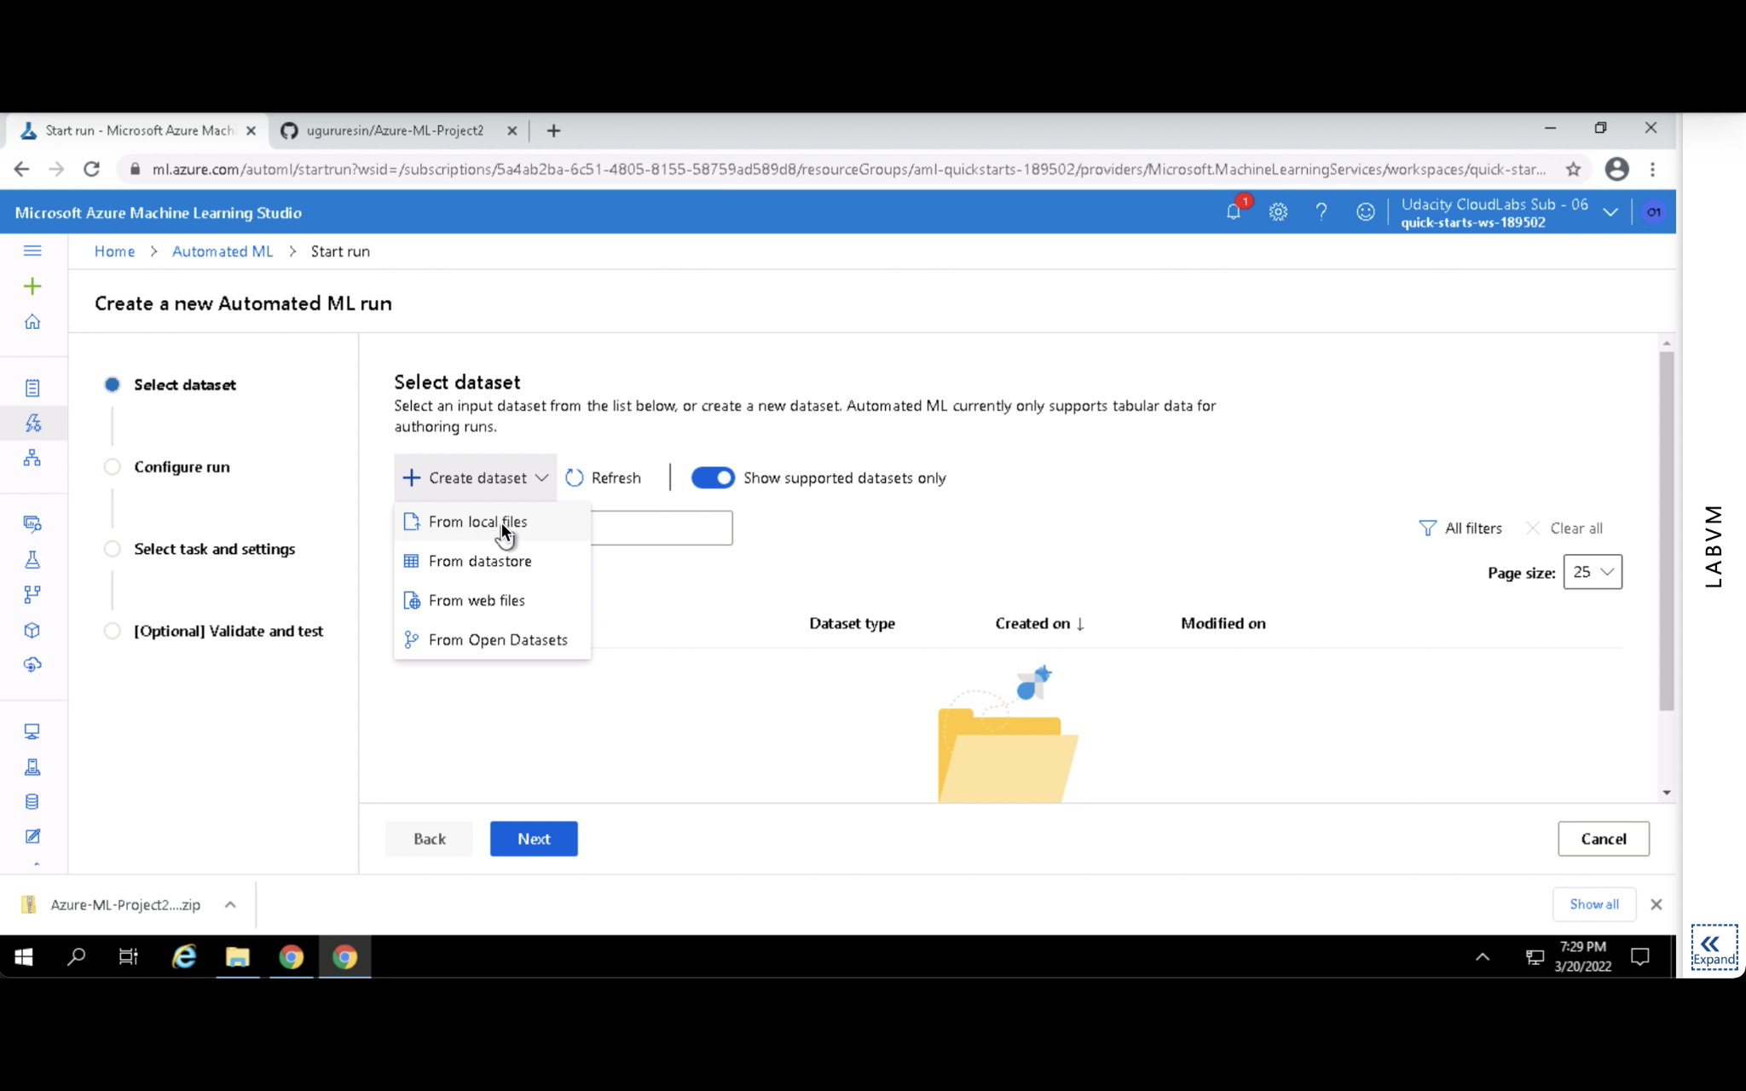

Named

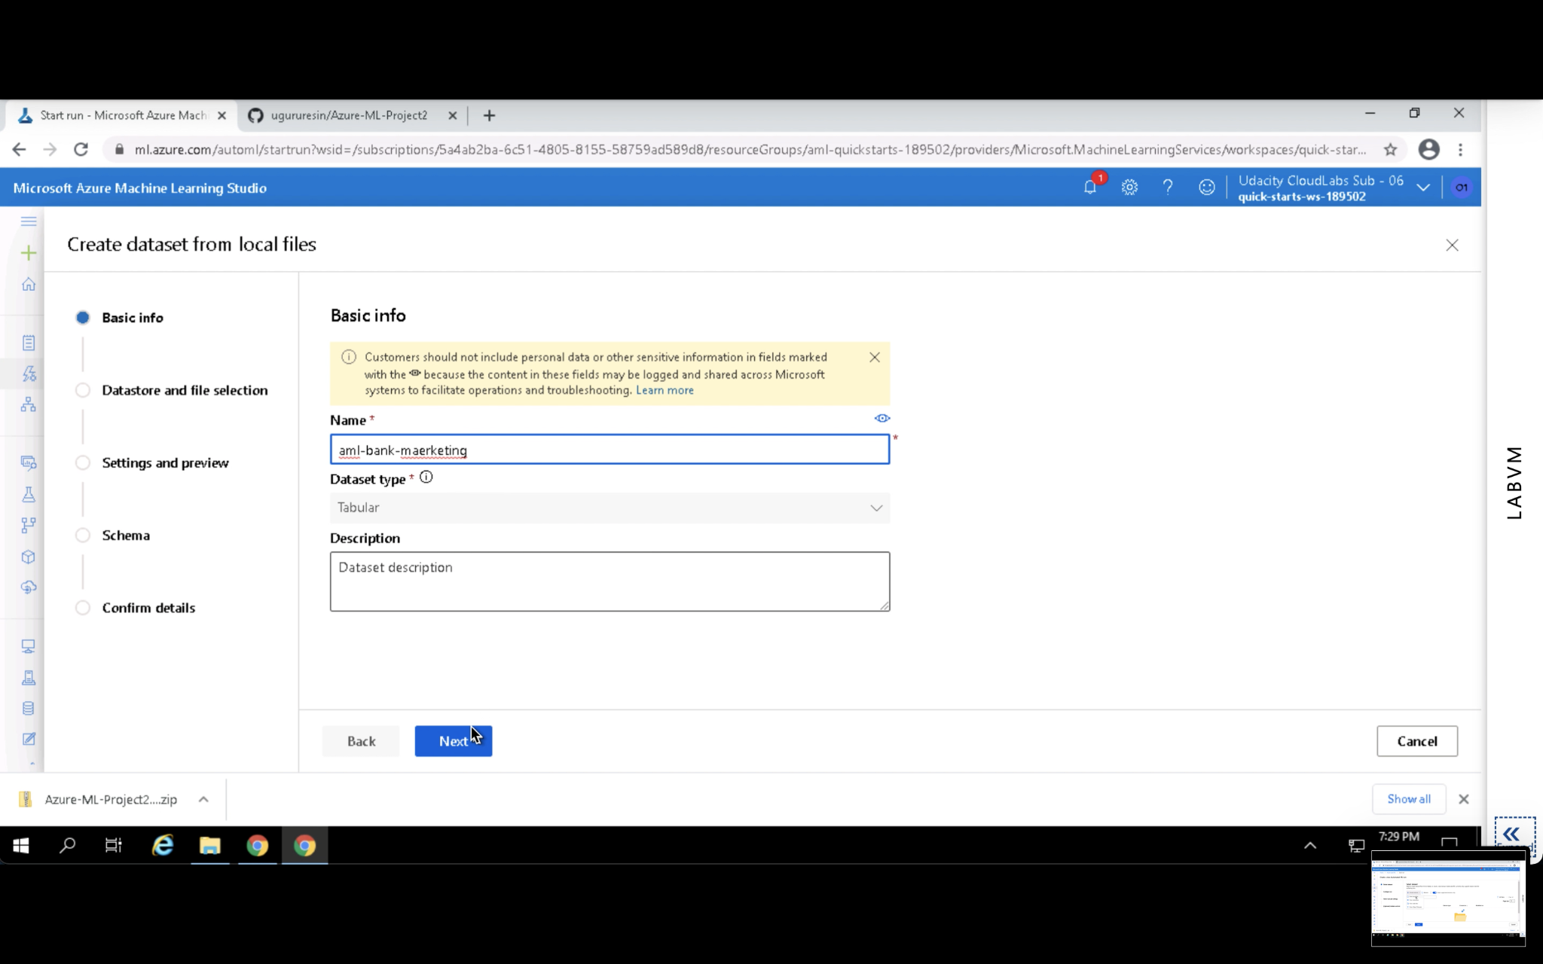

Dataset columns, rows, and data types were examined to ensure compatibility.

Check rows and columns

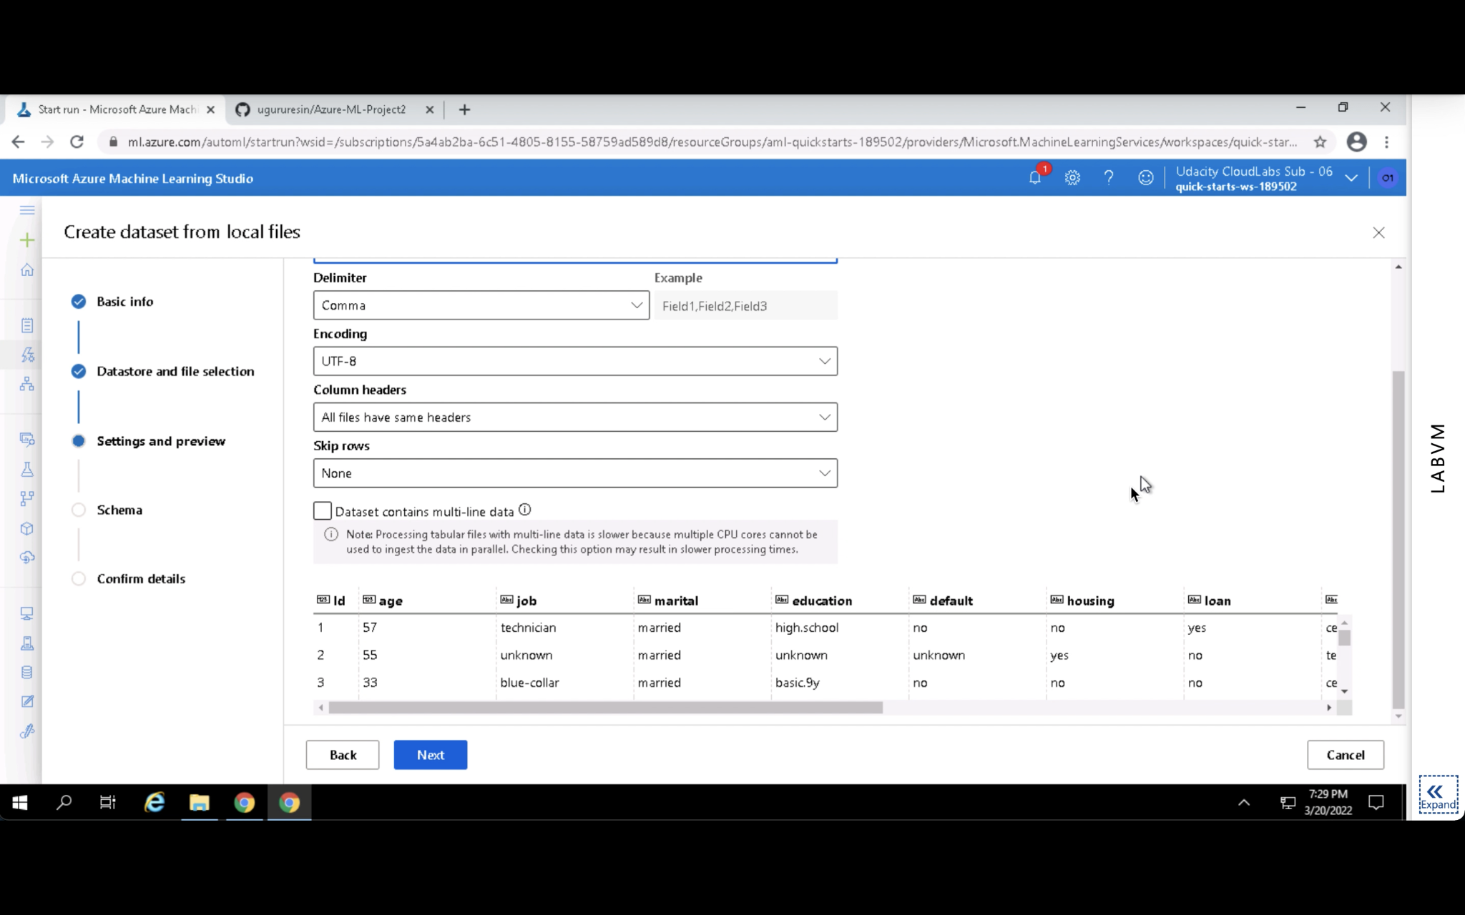

Check datatypes

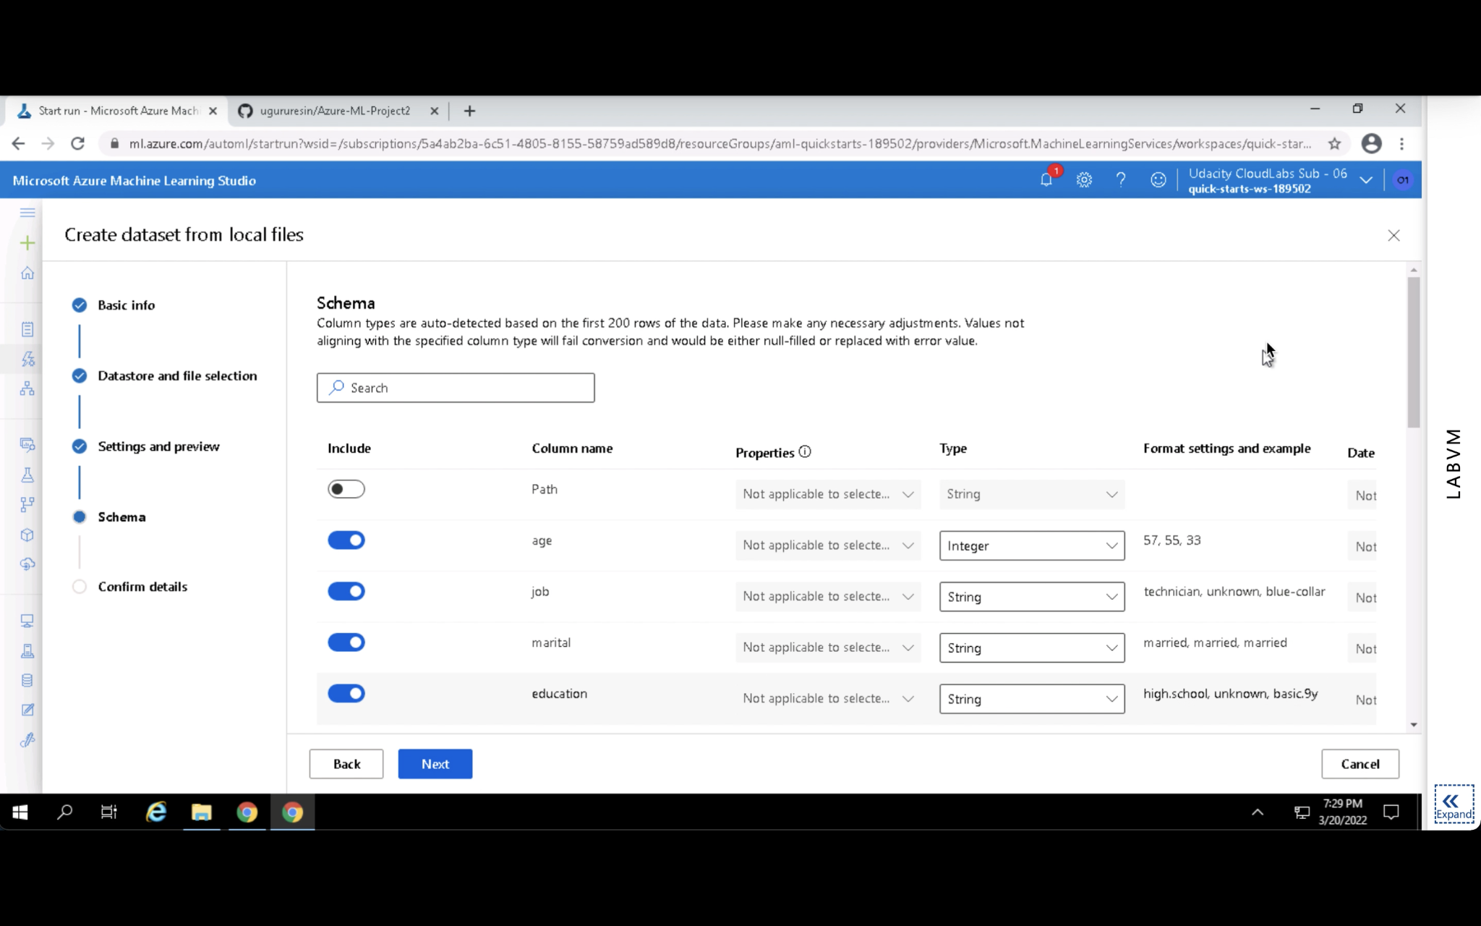

No issues were found with the dataset; it was ready for modeling.

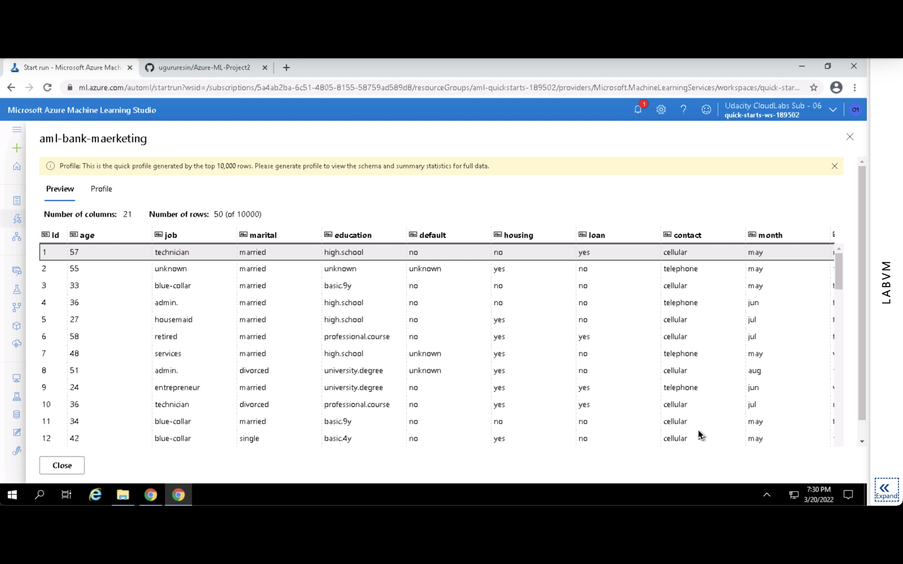

Compute cluster (DS3_V2) was created successfully for training purposes.

Creating

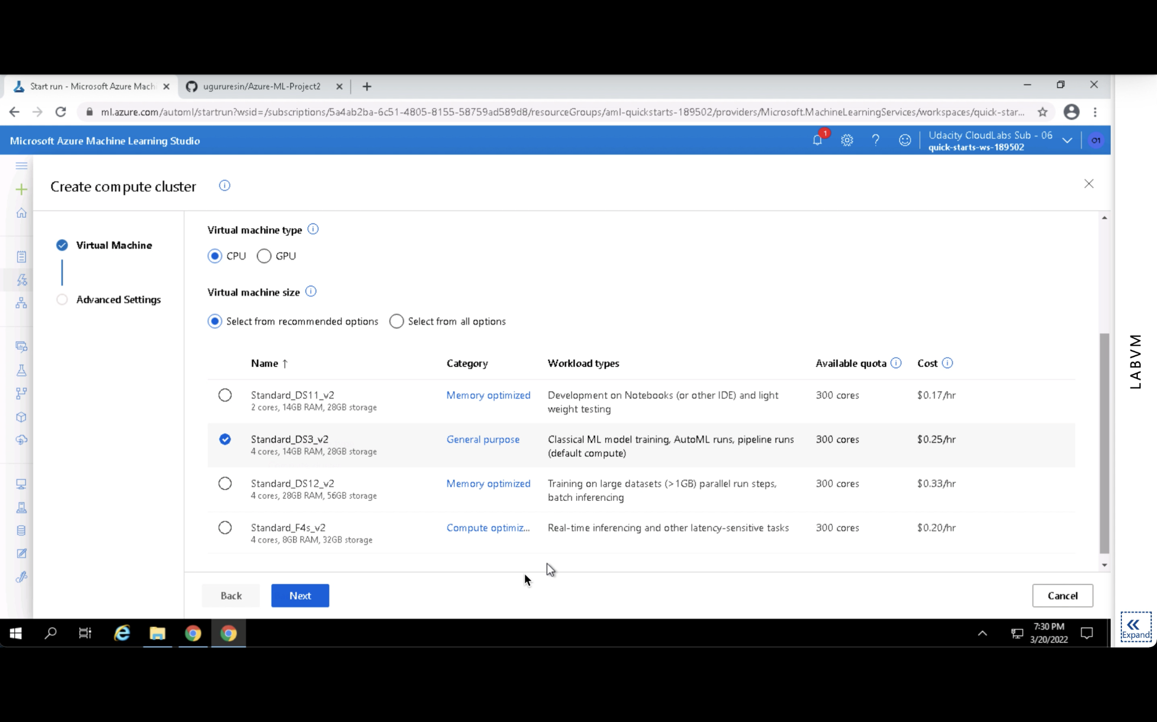

Successfully created

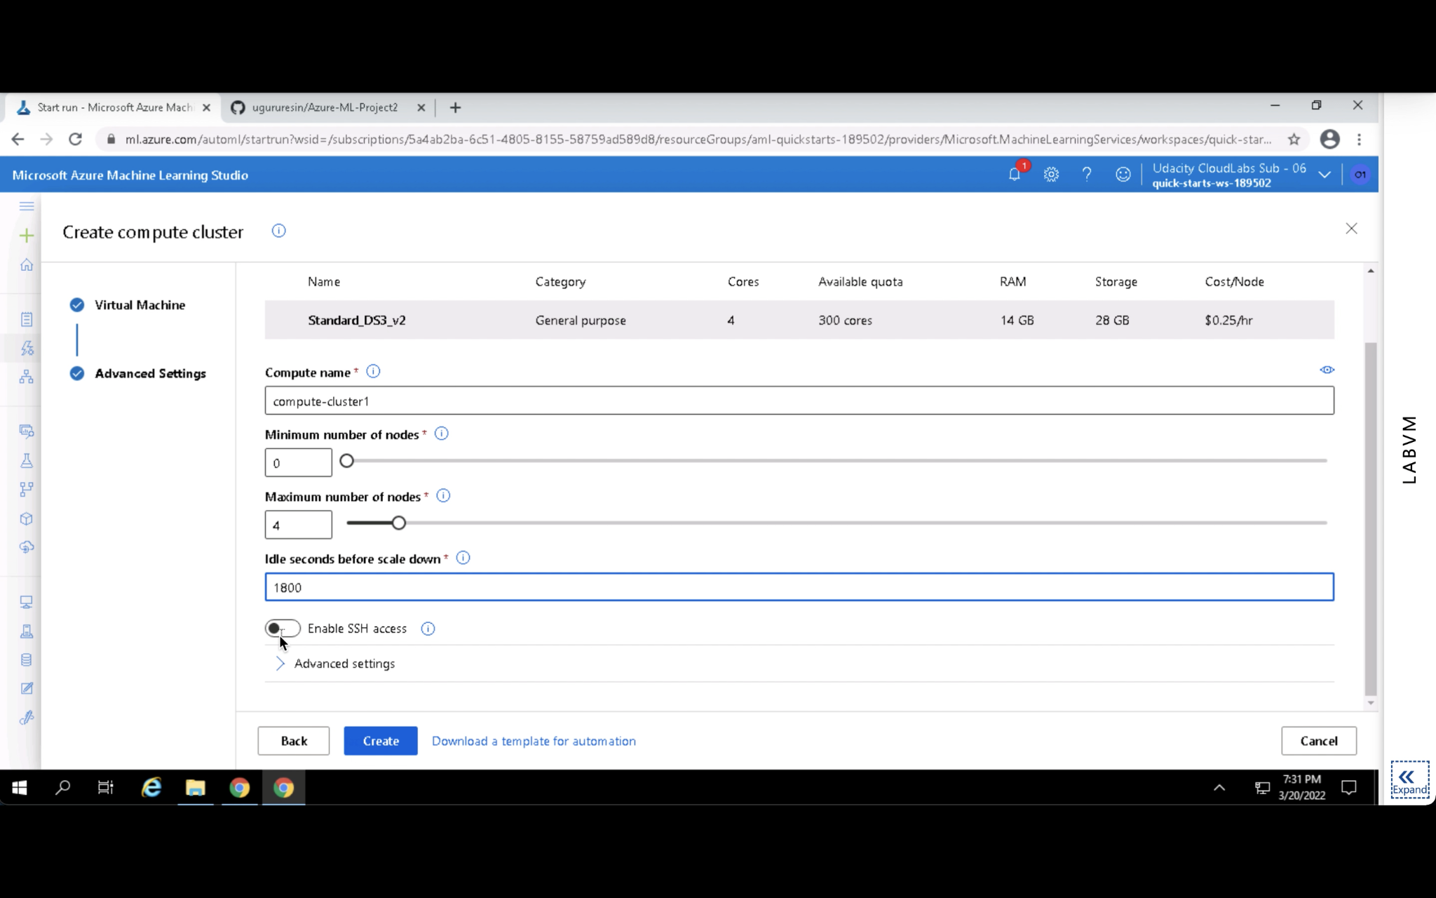

AutoML experiment was configured using the uploaded dataset and the compute cluster.

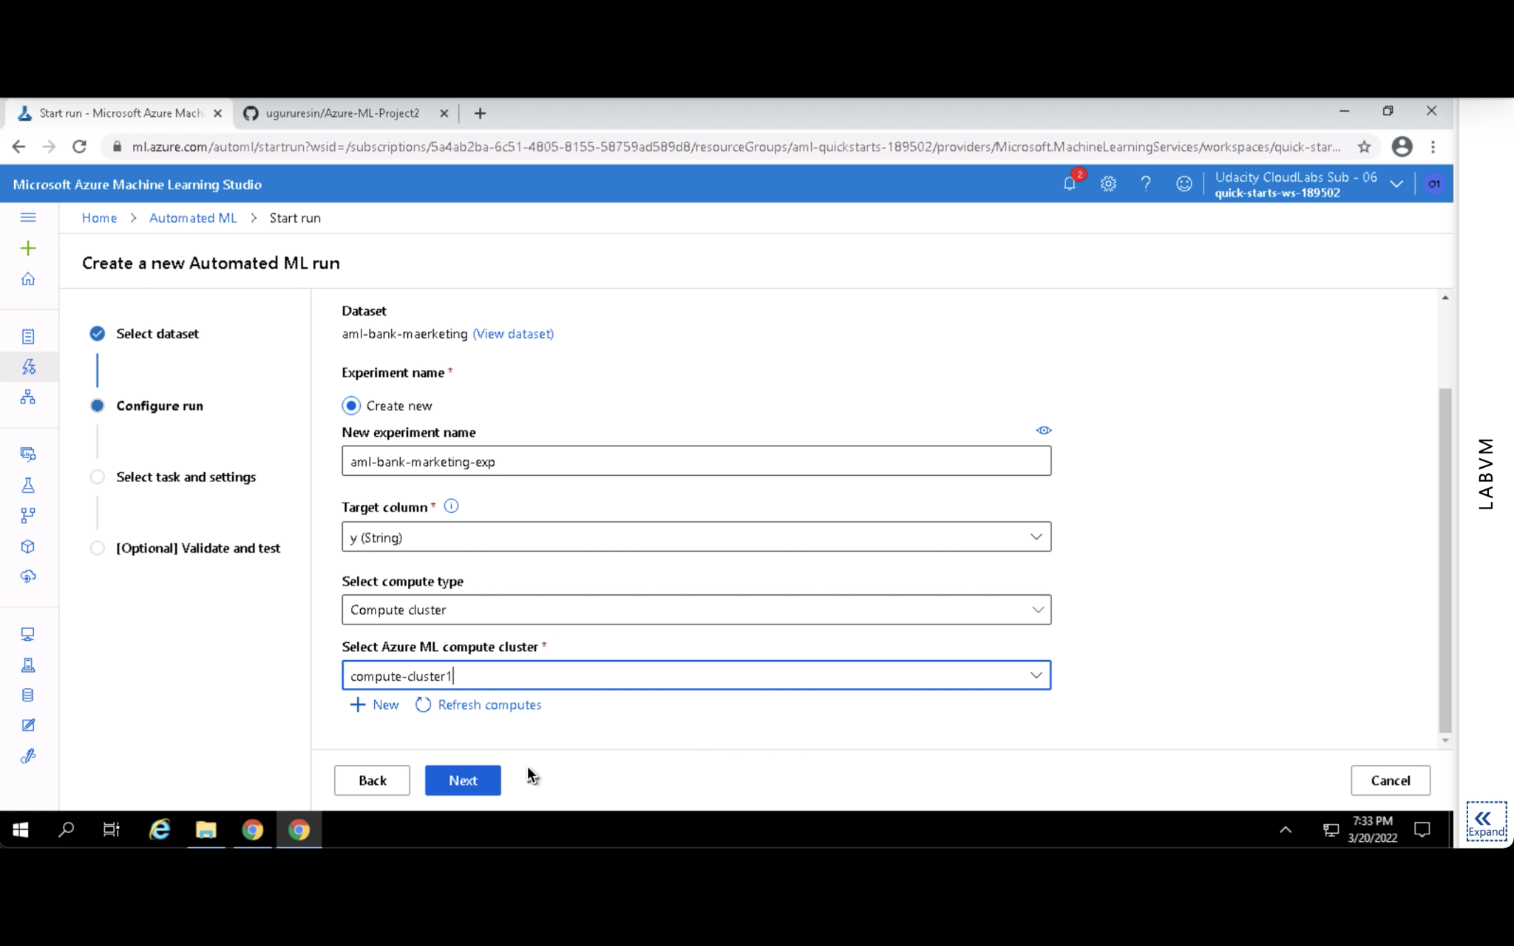

Classification was chosen as the task type.

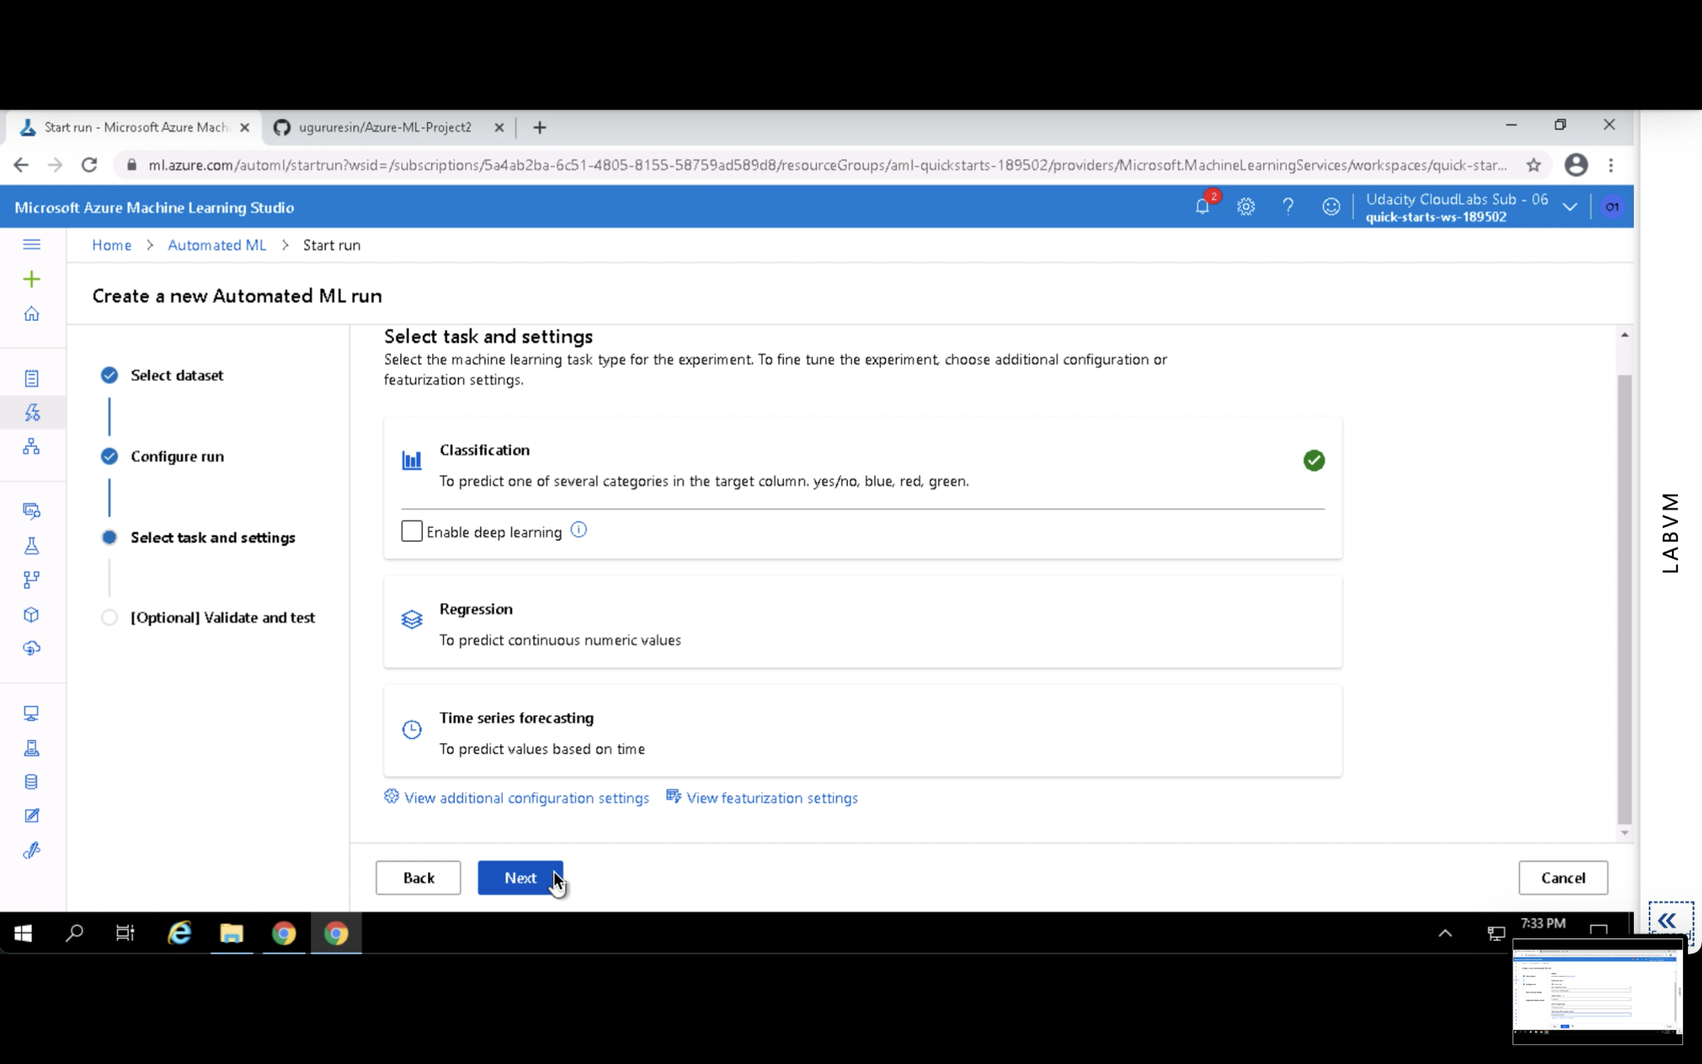

AUC was selected as the primary metric due to class imbalance.

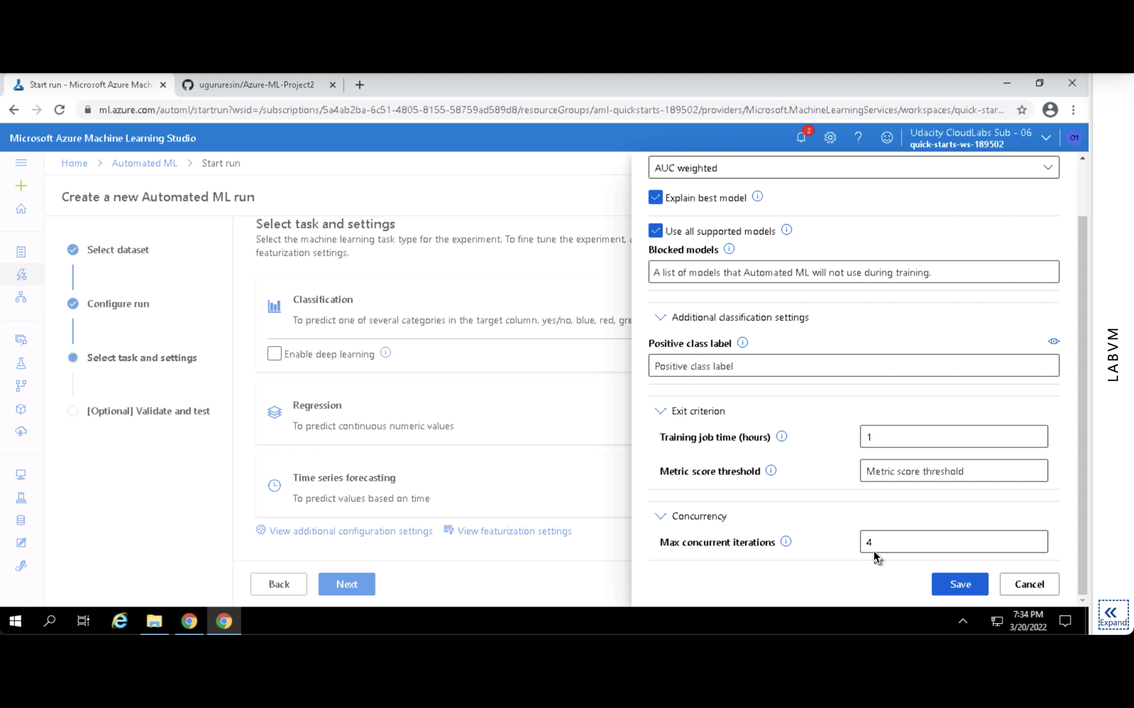

AutoML started training multiple models and completed them.

Start

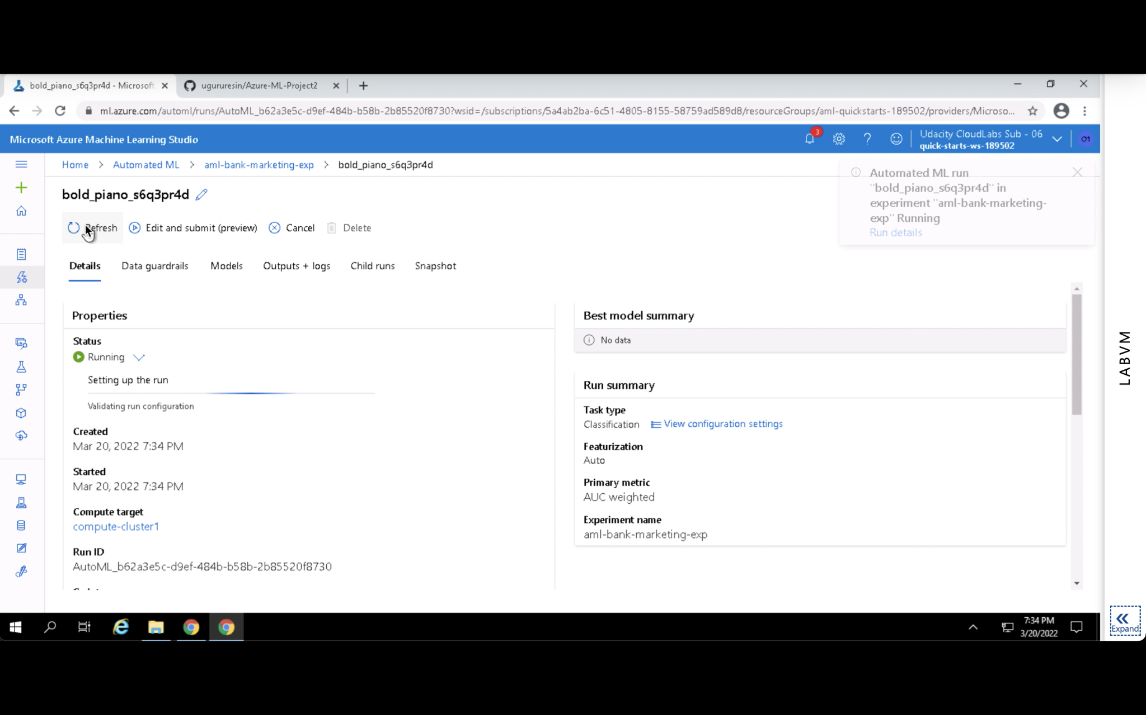

Finish

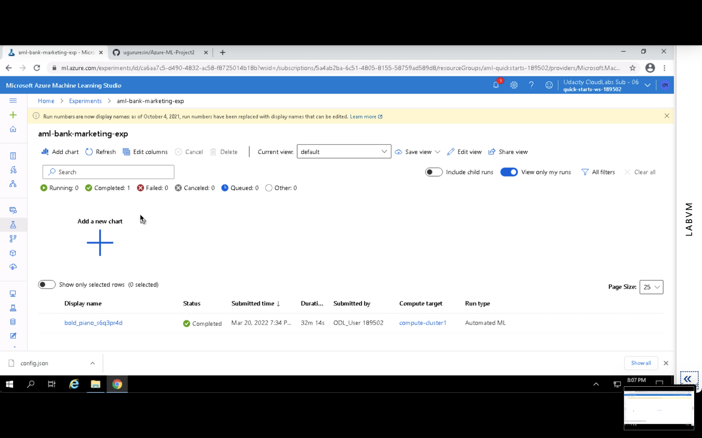

The best model achieved high performance:

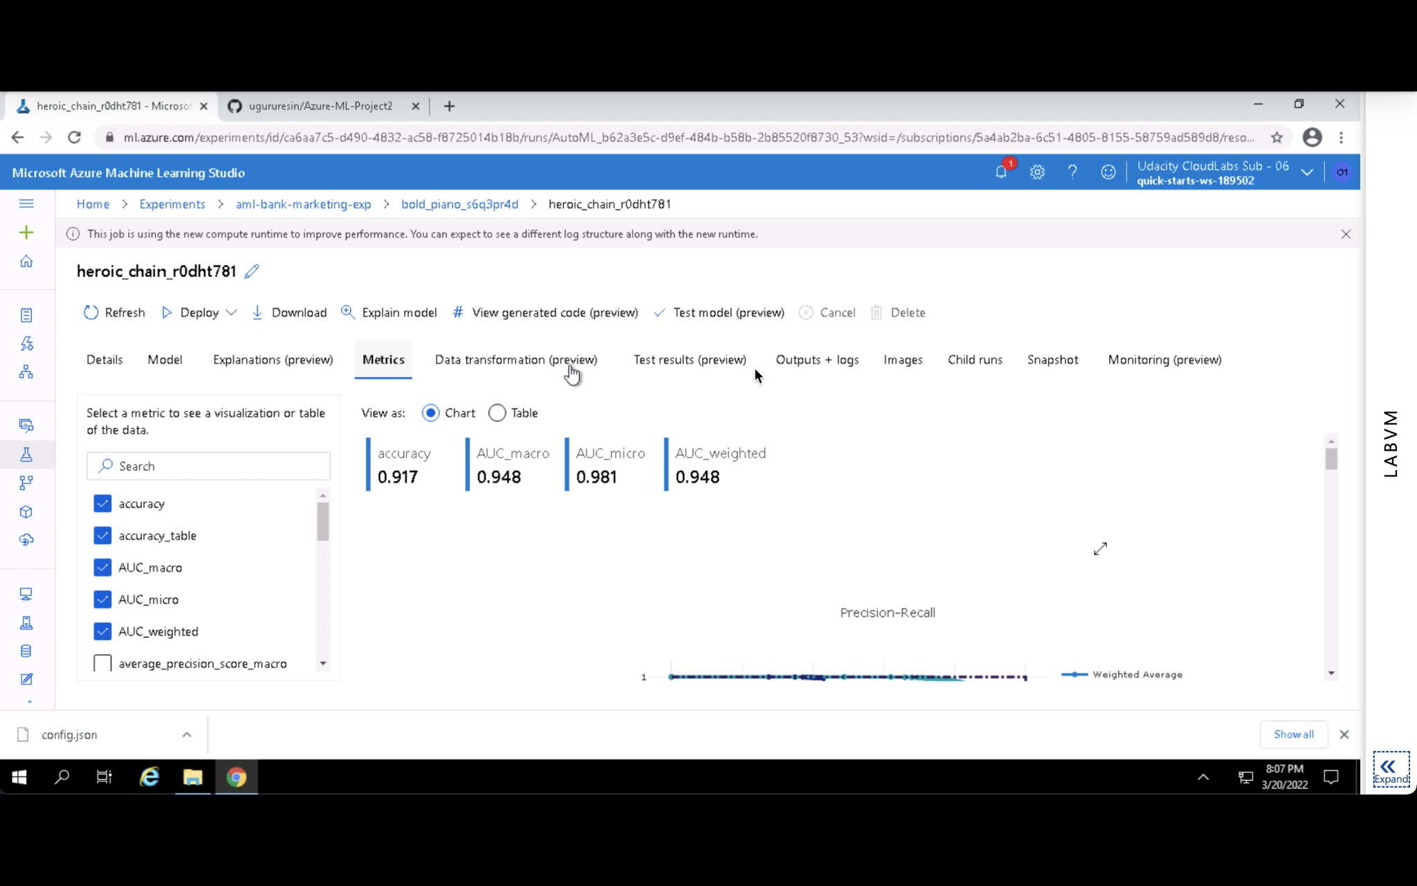

Evaluation visuals like precision-recall and ROC curves validated model's performance.

Precision-recall

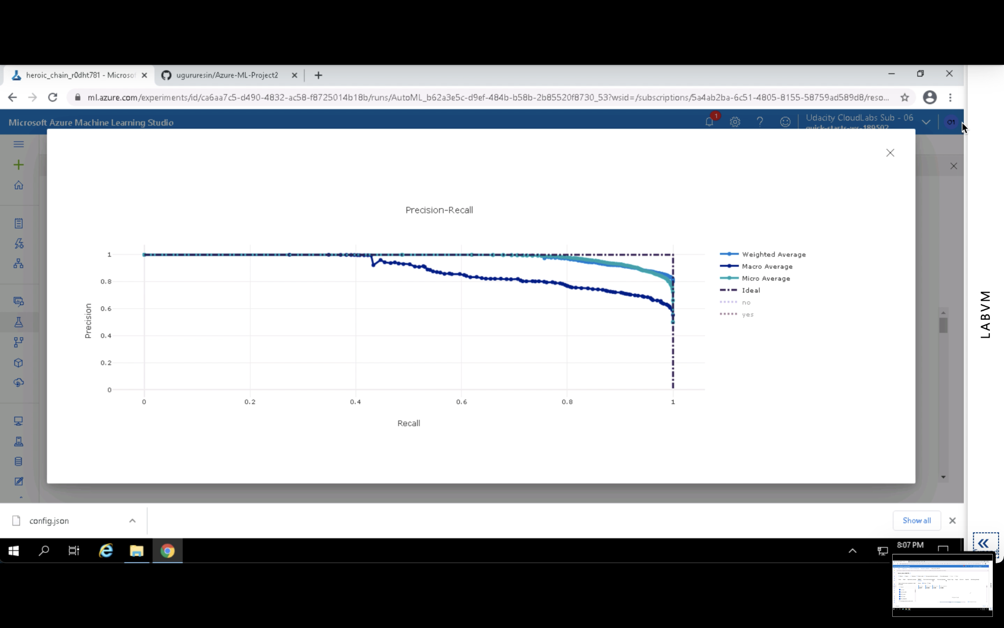

ROC curve

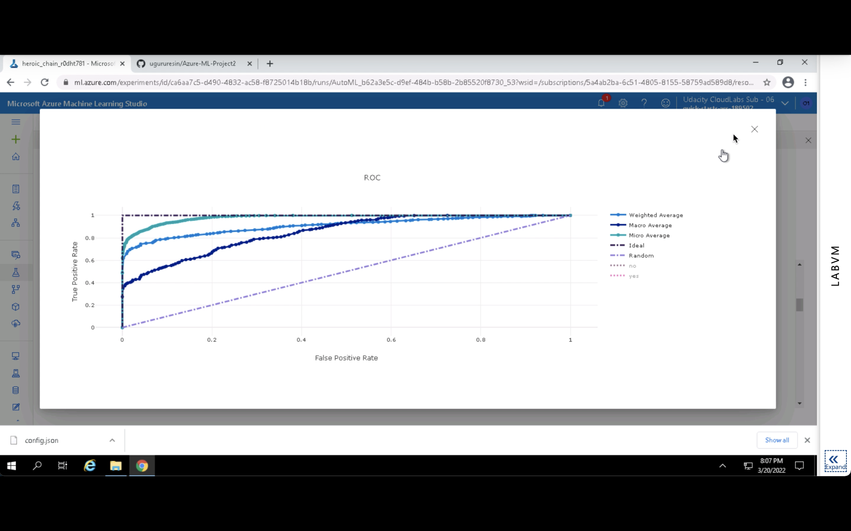

**Finish**